**Air Travel vs Car Travel:**

Driving is more dangerous than flying, with more than 5 million accidents compared to 20 accidents in flying. A more direct comparison per 100 million miles pits driving's 1.27 fatalities and 80 injuries against flying's lack of deaths and almost no injuries, which again shows air travel to be safer.

Below is the graph showing airline crash vs car crash, it clearly shows that fatalities in crashes are consistently above 30k per year, for the years between 1995-2019.

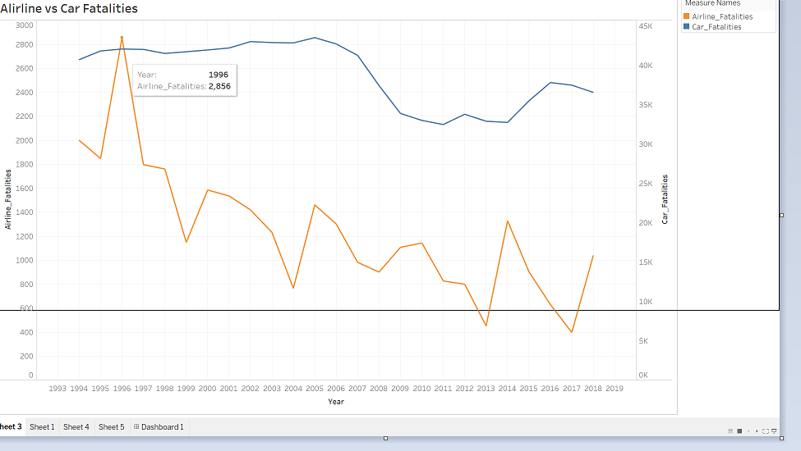

Top 10 Airline fatalities between 1985-2014 shows that fatalities gradually decreased over the years.

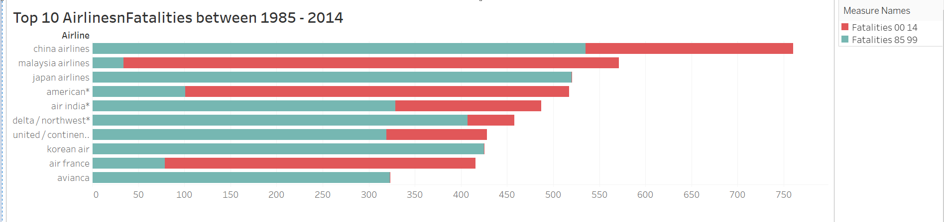

Below is the visual to show fatalities at carrier level.

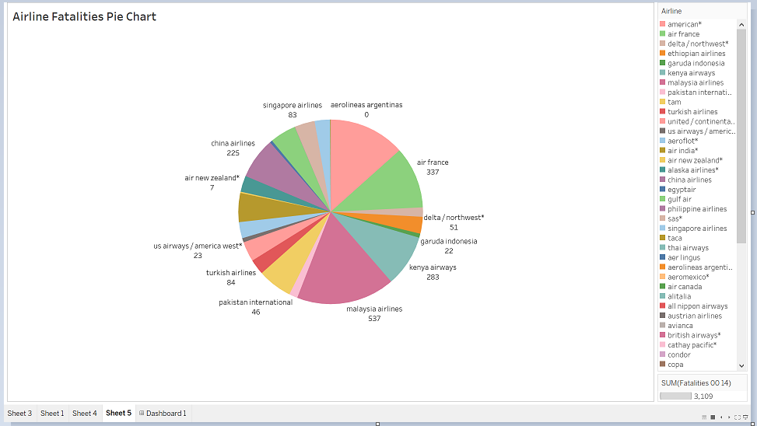

Airline crashes are catastrophic, involves more fatalities in a single incident, grabs more attention and makes people more sensitive to them. Car crashes happens every day, spread the loss over time, making it less noticeable. In 2017, zero deaths occurred on commercial airlines, compared to 40,000 fatalities in US alone in the same year. So, based on the above facts, I would say air travel is much safer than driving.

Reference:

1. https://traveltips.usatoday.com/air-travel-safer-car-travel-1581.html